How to complete the EVALUATION QUESTIONNAIRE OF THE WAY CONDUCTING CLASESS BY AN ACADEMIC TEACHER on the USOSweb website?
Go to your USOSweb account on the website usosweb.usos.pw.edu.pl, click the tab STUDENT’S SECTION. Go the SURVEYS section.
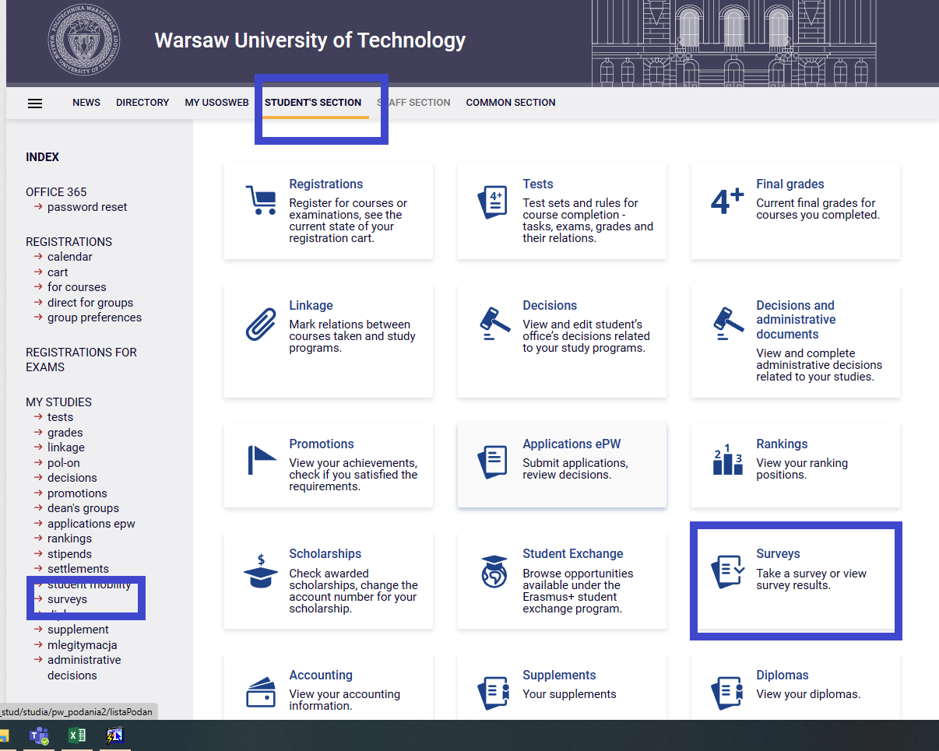
In the SURVEYS section you can see the evaluation of the courses you are enrolled in. Find the relevant
course and choose only this course teacher who actually taught you. If you can see a questionnaire of a
course you are not enrolled in, inform the Dean’s Office immediately.
In the relevant line, click ”COMPLETE SURVEY”.
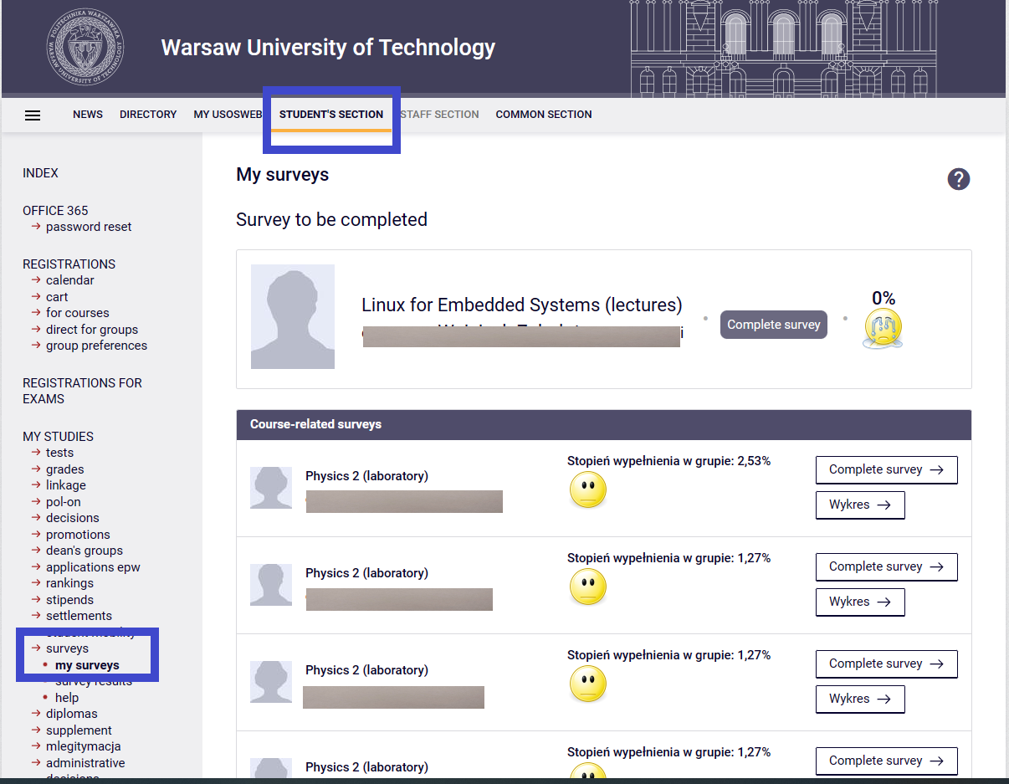

At the top of the completed questionnaire, you will find the information which course and which course teacher the questionnaire covers. Make sure you are evaluating the correct course. Give sincere and well-thought-out answers. Remember that your opinion is important.

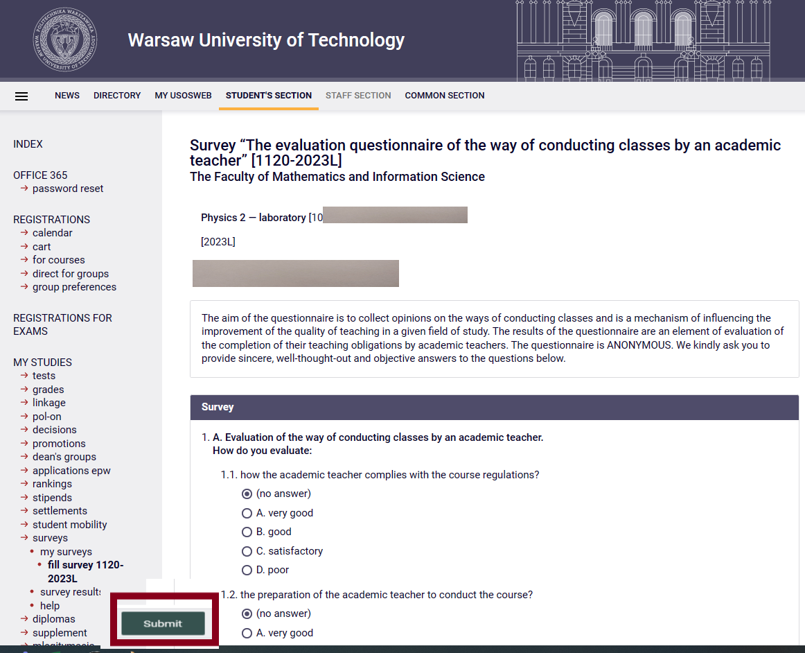

Check once again if you have correctly marked all your answers and if you have entered your comments in the Comments section. Click ”SUBMIT”. Thank you for completing the questionnaire.
Remember that you cannot evaluate the course again. On your account you will find questionnaires for other courses you are enrolled in.

NOTE: Remember that each survey can be completed only for 21 days and ends on the day of the last class!

How to complete the EVALUATION QUESTIONNAIRE OF THE WAY CONDUCTING CLASESS BY AN ACADEMIC TEACHER in the Mobile USOS PW app?
Go to the main site of the”Mobile USOS PW” app and choose on the left in the Menu Surveys. You will go to SURVEYS.

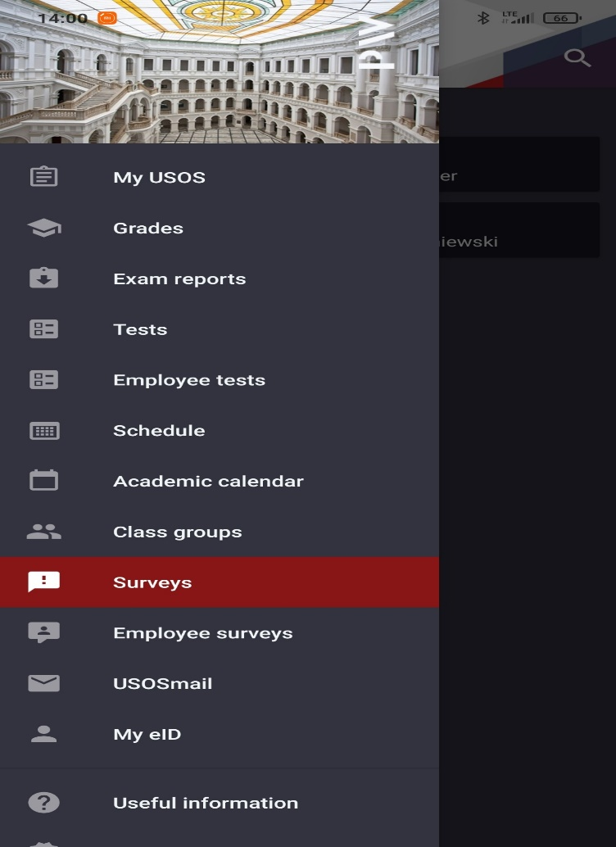

In the section ”SURVEYS” choose the relevant course. Make sure you are evaluating the correct course, i.e., if the course name, type of course and the name of the course teacher are as they should be. Choose the relevant questionnaire and complete the answers to the questions.

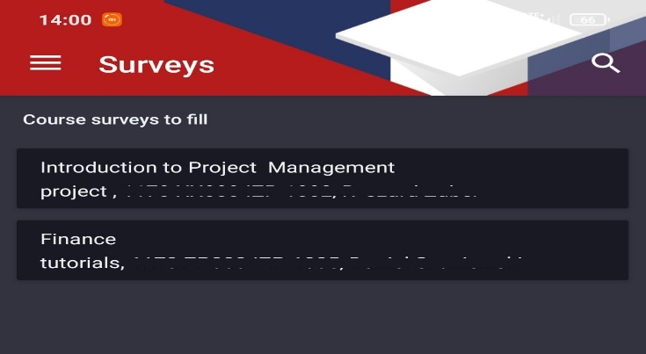

When completing the questionnaire, answer the questions one by one. Give sincere and well-thought-out answers. Remember that your opinion is important. The figure below shows a view of the questionnaire in the ”Mobile USOS PW” app.

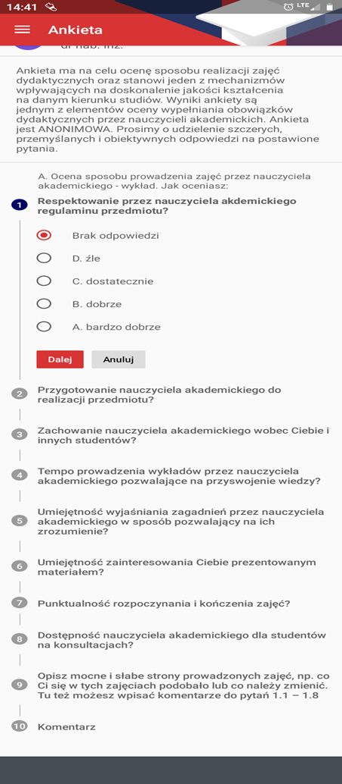

Check once again if you have correctly marked all your answers and if you have entered your comments in the Comments section. Click ”SEND”. Thank you for completing the questionnaire.
Remember that you cannot evaluate the course again. On your account you will find questionnaires for other courses you are enrolled in.

NOTE: Remember that each survey can be completed only for 21 days and ends on the day of the last class!

